**LAB Assignment#02**

***Subject:***

***MAD***

**Submitted By**

**Saleem Ahmed FA19-BCS-100**

**Submitted to**

**Sir Muhammad Kamran**

***COMSATS University Islamabad***

***Attock Campus***

## CODE:

import { StatusBar } from 'expo-status-bar';

import { Image, StyleSheet, Text, View ,TextInput, Button} from 'react-native';

const pic={uri:'https://www.jing.fm/clipimg/detail/77-776797_laboratory-clipart-science-supply-conical-flask-clip-art.png .png'}

export default function App() {

  return (

    <View style={styles.container}>

 <Image source = {{uri:'https://www.jing.fm/clipimg/detail/77-776797_laboratory-clipart-science-supply-conical-flask-clip-art.png .png'}}

   style = {{ width: 100, height: 100,top:120,right:170}}

   />

<Text style={styles.txt}> Visual website Optimizer</Text>

      <TextInput style={styles.iinput}

      placeholder = 'userName'

      ></TextInput>

<TextInput style={styles.iinput}

      placeholder = 'Password'

      ></TextInput>

      <View style={{height:200,width:200,top:70}}>

    <Button  title="Login" color="red"> </Button>

    </View>

    </View>

  );

}

const styles = StyleSheet.create({

  container: {

    height:600,

    width:500,

    alignSelf:'center',

    backgroundColor: 'black',

    alignItems: 'center',

    justifyContent: 'center',

  },

  iinput: {

    borderWidth : 1,

    borderColor : 'white',

    backgroundColor:'transparent',

    textShadowColor:'white',

    borderRadius : 3,

    bottom:200,

    width : 300,

    height : 10,

    padding : 10,

    margin : 10,

    color: 'white',

  },

  txt:

  {flex:1,

    color:'white',

  textAlign:'center',

  top:40,

  fontSize:30,

  alignItems:'center',

  fontWeight: 'bold',width:250}

});

**Design my screen:**

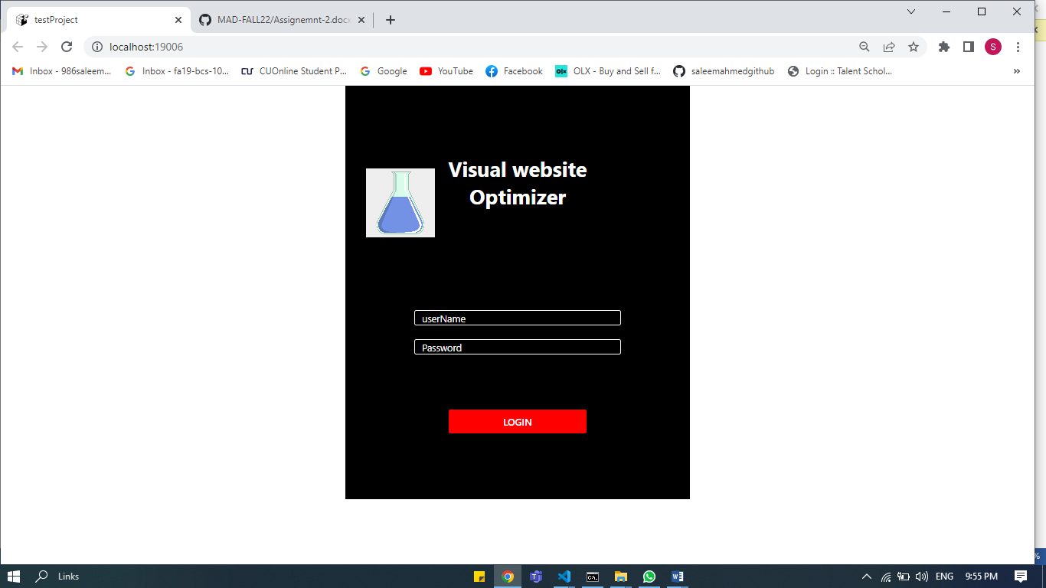

Link:

<https://www.pinterest.com/pin/337418197056192602/?mt=login>

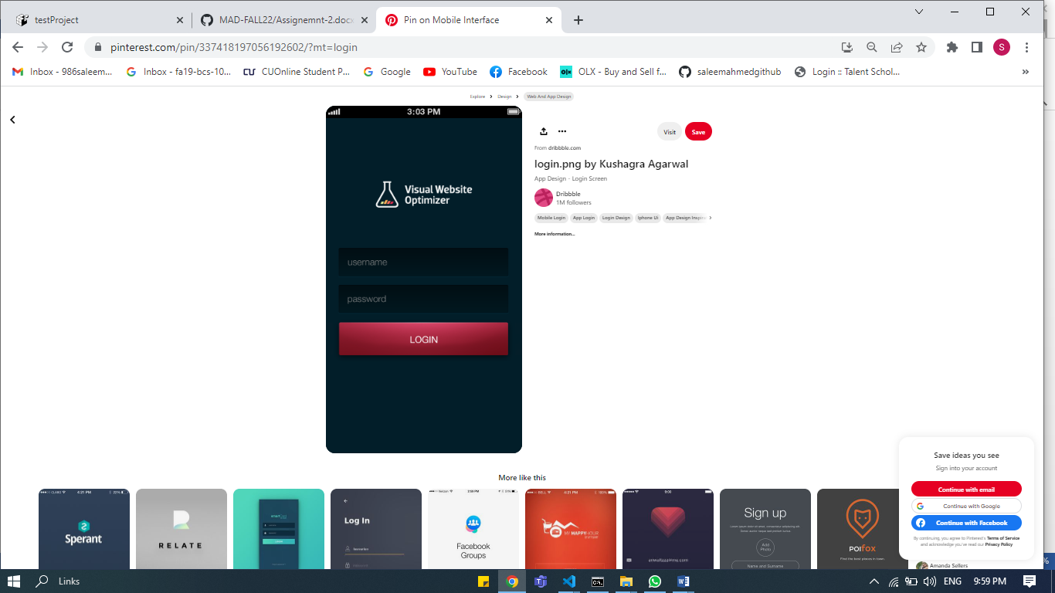

**END**